Practical–3.2: Exploring Multiple Activities
Aim
To develop an Android application that demonstrates interaction between multiple activities by navigating between screens and presenting user-specific content dynamically.
Problem Statement
Design an Android application consisting of two activities where the first activity acts as a welcome screen to collect basic user input, and the second activity displays a personalized message based on the input received, demonstrating activity-to-activity communication.
STEP 1: Create a New Android Project
Open Android Studio
- Click New Project
Select Template
- Choose Empty Views Activity
- Click Next
Project Configuration
- Name:
WelcomeMessageApp
- Language:
Java
- Minimum SDK:
API 21 (Android 5.0)
- Build configuration language:
Groovy (default)
Click Finish
Wait for Gradle sync to complete.
activity_mainXML: SOURCECODE:
<?xml version="1.0" encoding="utf-8"?>
<LinearLayout xmlns:android="http://schemas.android.com/apk/res/android"
android:layout_width="match_parent"
android:layout_height="match_parent"
android:orientation="vertical"
android:gravity="center"
android:padding="24dp">
<TextView
android:layout_width="wrap_content"
android:layout_height="wrap_content"
android:text="Welcome!"
android:textSize="26sp"
android:textStyle="bold"
android:layout_marginBottom="20dp" />
<EditText
android:id="@+id/etName"
android:layout_width="match_parent"
android:layout_height="wrap_content"
android:hint="Enter your name"
android:inputType="textPersonName"
android:layout_marginBottom="16dp" />
<Button
android:id="@+id/btnNext"
android:layout_width="wrap_content"
android:layout_height="wrap_content"
android:text="Continue" />
</LinearLayout>
Concept & Logic
- TextView → welcomes the user
- EditText → takes user input (name)
- Button → moves to second activity
STEP 3: Create Second Activity (Display Screen)
Create New Activity
- Right-click on java → com.example.multipleactivities
- Select New → Activity → Empty Views Activity
Activity Configuration
Fill details exactly:
- Activity Name:
SecondActivity
- Layout Name:
activity_second
- Language:
Java
Click Finish
Wait for Gradle to sync.
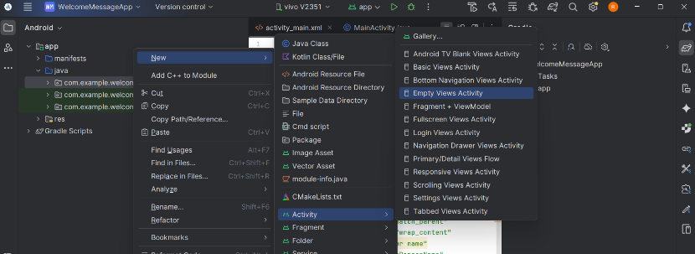

Activity_second.xml:code
<?xml version="1.0" encoding="utf-8"?>
<LinearLayout xmlns:android="http://schemas.android.com/apk/res/android"
android:layout_width="match_parent"
android:layout_height="match_parent"
android:orientation="vertical"
android:gravity="center"
android:padding="24dp">
<TextView
android:id="@+id/tvMessage"
android:layout_width="wrap_content"
android:layout_height="wrap_content"
android:text="Hello User!"
android:textSize="24sp"
android:textStyle="bold" />
</LinearLayout>
Second_activity.java
package com.example.welcomemessageapp;
import android.os.Bundle;
import android.widget.TextView;
import androidx.appcompat.app.AppCompatActivity;
public class SecondActivity extends AppCompatActivity {
TextView tvMessage;
@Override
protected void onCreate(Bundle savedInstanceState) {
super.onCreate(savedInstanceState);
setContentView(R.layout.activity_second);
// Link TextView
tvMessage = findViewById(R.id.tvMessage);
// Get data sent from MainActivity
String name = getIntent().getStringExtra("username");
// Display personalized message
tvMessage.setText("Hello, " + name + "! Welcome to the App.");
}
}
MainActivity.java
package com.example.welcomemessageapp;
import android.content.Intent;
import android.os.Bundle;
import android.view.View;
import android.widget.Button;
import android.widget.EditText;
import androidx.appcompat.app.AppCompatActivity;
public class MainActivity extends AppCompatActivity {
EditText etName;
Button btnNext;
@Override
protected void onCreate(Bundle savedInstanceState) {
super.onCreate(savedInstanceState);
setContentView(R.layout.activity_main);
// Linking UI components with Java
etName = findViewById(R.id.etName);
btnNext = findViewById(R.id.btnNext);
// Button click event
btnNext.setOnClickListener(new View.OnClickListener() {
@Override
public void onClick(View view) {
// Get user input
String name = etName.getText().toString();
// Create Intent to move to SecondActivity
Intent intent = new Intent(MainActivity.this, com.example.welcomemessageapp.SecondActivity.class);
// Pass data using Intent
intent.putExtra("username", name);
// Start second activity
startActivity(intent);
}
});
}
}
Run the application

